Sunrise Water Co.
9098 W. Pinnacle Peak Road
Peoria, AZ 85383
623-972-6133
www.jdcwater.com

WATER CONSERVATION

Water Conservation is important for everyone. We live in an arid area and water conservation efforts and water saving behaviors will help ensure that we have enough water for ourselves and for future generations.

Fall Is Here Time For:

Irrigation System Maintenance

Develop written operation and maintenance instructions for you including the following:

- Watering schedule
- Seasonal adjustments
- Winterizing 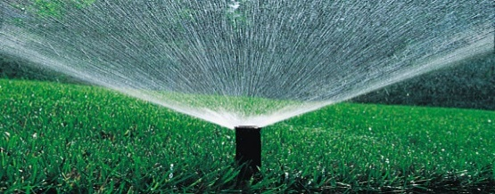
- Spring reactivation
- Perform water audits

Remember that it is important to routinely check for damaged sprinkler heads, inadequate coverage, clogged nozzles, and leaks. Regularly scheduled assessments can help you do this.

Landscape Watering and Maintenance Calendar

January: Flush your irrigation system and check filters July: Check your controller settings

February: Move emitters out to drip line of trees August: Check emitters and sprinklers

March: Adjust your controller for spring schedule September: Move emitters out to drip line of trees

April: Check of your irrigation system October: Adjust your controller for fall schedule

May: Adjust your controller for summer schedule November: Check your irrigation system

June: Check emitters and sprinklers December: Adjust your controller for winter schedule

For best results, try watering during non-daylight hours to keep evaporation loss to a minimum.

Do not over water plants and lawns. Avoid water runoff into streets. It’s better to water your lawn for three 10-minute sessions, a half-hour apart, than it is to water steadily for 30 minutes and cause runoff.

HOW TO CHECK FOR LEAKS

While you’re carefully watching your water usage, it’s important to make sure that water is not slipping away due to undetected leaks in your water system. Here’s a simple procedure that can tell you if you have a leak and how much water you may be losing.

Locate your water meter. It is usually located near the street in front of your home.

- Read the meter twice- first at night after the day’s water use has ended, and again in the morning before any water is used.
- Subtract the first number from the second reading to tell how much water (if any) leaked out overnight.
- If you suspect a leak, your pipes and connections should be checked and repaired quickly.

Free low water using plant brochures, landscape watering guides and water conservation publications are available by calling our office at 623-972-6133 or visit our web site www.jdcwater.com

Additional Information Available at:

City of Peoria
www.peoria.gov

Arizona Department of Water Resources www.azwater.gov

Arizona Municipal Water Users Association www.amwua.org

Water – Use it Wisely www.wateruseitwisely.com

